
NATI NALISM
SOCIAL STUDIES 20-1
TO WHAT EXTENT SHOULD WE EMBRACE

Mrs. Klapp
Room: 104
Website: http://klappsocial11rockstars.weebly.cm
Remind: rmd.at/9e3fe7
Google Classroom: https://classroom.google.com/c/MTkxNjAxMTEyOFpa
Flipped Classroom

Social studies provides opportunities for students to develop the attitudes, skills and knowledge that will enable them to become engaged, active, informed and responsible citizens. Recognition and respect for individual and collective identity is essential in a pluralistic and democratic society. Social studies helps students develop their sense of self and community, encouraging them to affirm their place as citizens in an inclusive, democratic society.

The Alberta Social Studies Kindergarten to Grade 12 Program of Studies meets the needs and reflects the nature of 21st century learners. It has at its heart the concepts of citizenship and identity in the Canadian context. The program reflects multiple perspectives, including Aboriginal and Francophone, that contribute to Canada’s evolving realities. It fosters the building of a society that is pluralistic, bilingual, multicultural, inclusive and democratic. The program emphasizes the importance of diversity and respect for differences as well as the need for social cohesion and the effective functioning of society. It promotes a sense of belonging and acceptance in students as they engage in active and responsible citizenship at the local, community, provincial, national and global level.

Central to the vision of the Alberta social studies program is the recognition of the diversity of experiences and perspectives and the pluralistic nature of Canadian society. Pluralism builds upon Canada’s historical and constitutional foundations, which reflect the country’s Aboriginal heritage, bilingual nature and multicultural realities. A pluralistic view recognizes that citizenship and identity are shaped by multiple factors such as culture, language, environment, gender, ideology, religion, spirituality and philosophy.

Social studies is the study of people in relation to each other and to their world. It is an issues-focused and inquiry-based interdisciplinary subject that draws upon history, geography, ecology, economics, law, philosophy, political science and other social science disciplines. Social studies fosters students understanding of and involvement in practical and ethical issues that face their communities and humankind. Social studies is integral to the process of enabling students to develop an understanding of who they are, what they want to become and the society in which they want to live.

In social studies 20-1, Students will explore the complexities of nationalism in Canadian and international contexts. They will study the origins of nationalism and the influence of nationalism on regional, international and global relations. The infusion of multiple perspectives will allow students to develop understandings of nationalism and how nationalism contributes to the citizenship and identities of peoples in Canada.

While nationalism has historically examined the relationship of the citizen to the state, contemporary understandings of nationalism include evolving individual, collective, national and state realities. Exploring the complexities of nationalism will contribute to an understanding and appreciation of the interrelationships among nation, nationalism, internationalism, globalization, and citizenship and identity. Developing understandings of the various points of view associated with nationalism as well as an appreciation for the perspectives of others will encourage students to develop personal and civic responses to emergent issues related to nationalism.

RESOURCES:

Primary Resource:

Exploring Nationalism Gardner, Hoogeveen, McDevitt, Scully, McGraw-Hill Ryerson, 2008..

COURSE ASSESSMENT:

You will be assessed and evaluated with evidence of learning in the following areas:

Course Work - 70%

30%

40%

20%

Tests and Quizzes

*minimum of three formal
summative assessments that will be connected to the related issues of the curriculum

*tests will include multiple choice and written response questions grounded in the skills and outcomes of the curriculum

Assignments
and Projects

*one project or performance
task per related issues

*up to three defense of position papers (major essays)

*up to three perspective essays
(minor essays)
*novel study
*final paper demonstrating mastery will be weighted more heavily
*Flipped Classroom
*writing skills activities / progressions built into papers

Participation and
Daily Work

*classroom tasks & assignments homework completion
* Field trip to Calgary
*regular reflections and contributions to a learning
*Field Trip to Calgary Military Museum December.
*assessment of participation and engagement in classroom activities

Final Exam - 30% Multiple Choice 50% Written 50%
(program concepts and skills) (major and minor task)

CLASSROOM BEHAVIOR and PARTICIPATION

You will only get out of your education what you put into it! Be an active learner – think critically and ask questions. There will be ample opportunity for discussion in class. However, in order to create an environment where all feel welcome to participate, regardless of one’s perspective, it is essential for some basic rules to be followed:

- Show respect for anyone who is speaking by being a good listener
- Before speaking please raise your hand to be acknowledged - do not interrupt another person
- Do not make disparaging remarks that would in any way offend someone
Cheating of any kind will not be tolerated. Students are expected to do their own work. A zero will be given to any student caught cheating. In short, do not put yourself in a position where this might apply to you.

There will be no food permitted into the classroom, unless specified by the teacher on special occasions. Please do not bring cell phones to class. If your teacher perceives a cell phone or music device as a distraction it may be confiscated for the period. Listening to music on an mp3 player or an Ipod may be permitted during individual work time, but always at the discretion of the teacher. Earphones should not be used unless clear permission has been given to do so.

ASSIGNMENTS and TESTS

All assignments will be given due dates and these dates will be firm (unless unforeseen and acceptable circumstances arise – always at the discretion of the teacher). There will be no surprises. Unexcused late assignments may not be marked. If there are circumstances that create a problem for completion of an assignment, a student should approach the teacher for an extension. If the situation is deemed acceptable by the teacher, an extension may be granted.

Missed tests or quizzes must be excused by the teacher prior to the writing date (unless special circumstances do not permit). A responsible student does not surprise a teacher with missed tests and late assignments. All re-writing of tests and quizzes will take place outside of class time and it will be the responsibility of the student to make those arrangements. The writing of missed tests must take place within one week of a student returning.

ATTENDANCE and LATES

Attendance will be handled according to school policy. School policy states that you must have a parent or guardian call the school to excuse any non-school related absence. If an absence is not excused a student will be sent to the office to deal with the unexcused absence.

If you come late to a class and the door is closed, please knock once and wait patiently and quietly in the hallway for admittance into class. The teacher will let you in at the most convenient time for them and for the rest of class. More than one late in a week may result in a ‘prime time’, while persistent lateness will lead to an attendance contract and administrative involvement. Chronic attendance problems may lead to withdrawal from the course.

MATERIALS

There are certain things that all students will be expected to bring to class every day. These materials include: pen, pencil, social studies binder, and appropriate textbooks.

Students will be asked to keep an organized notebook which will serve as a learning journal for the semester. There are a variety of formats a student can use to chronicle their learning, including:

    - Traditional written journal recorded and stored in a binder, folder etc.
    - Electronic written journal placed on a memory stick, re-writeable disc etc.
    - Electronic written journal online stored in a blog, website etc.

FINAL THOUGHTS

There are a great many historical and modern day facts, figures, and concepts that you will be expected to learn through the course of you social studies ‘career’, but they all pale in comparison to the ultimate goal of creating critically thinking, active and responsible citizens that are prepared to contribute in a positive way to our Canadian, as well as our global, society – good luck and have fun!

Remember, you get out of your education only as much as you put into it. You chose your attitude!

“Be the change you want to see in the world.” Mohandas Gandhi

“Some people see things as they are and ask 'why'? I see things as they have never been and ask 'why not'?”
George Bernard Shaw

“If you think you can, you can. And if you think you can't, you're right.” Henry Ford
Throughout the social studies 20-1 course students will be engaged with a key issue that is interconnected to four related issue questions. There is one key outcome that students will work towards, again, with four general outcomes guiding their journey. Within each related issue there are specific outcomes that reflect important values and attitudes, including knowledge and understanding outcomes.

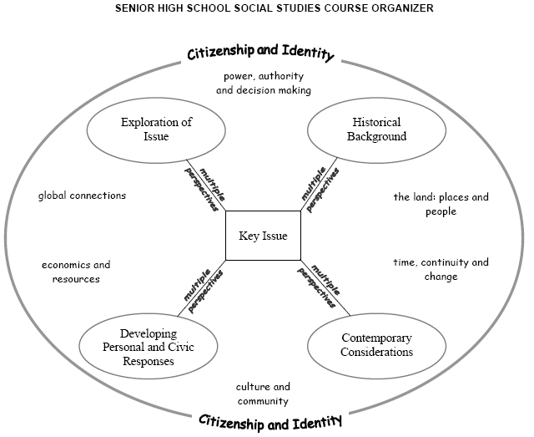

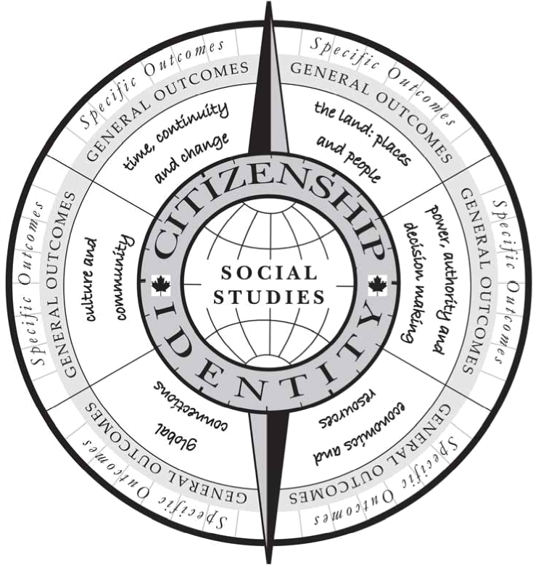

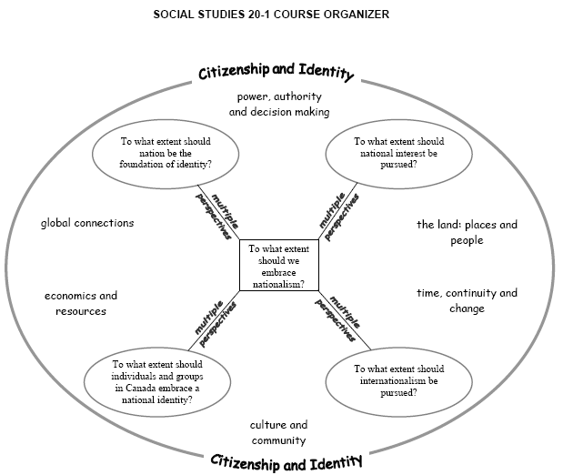

NATI NALISM
SOCIAL STUDIES 20-1
TO WHAT EXTENT SHOULD WE EMBRACE

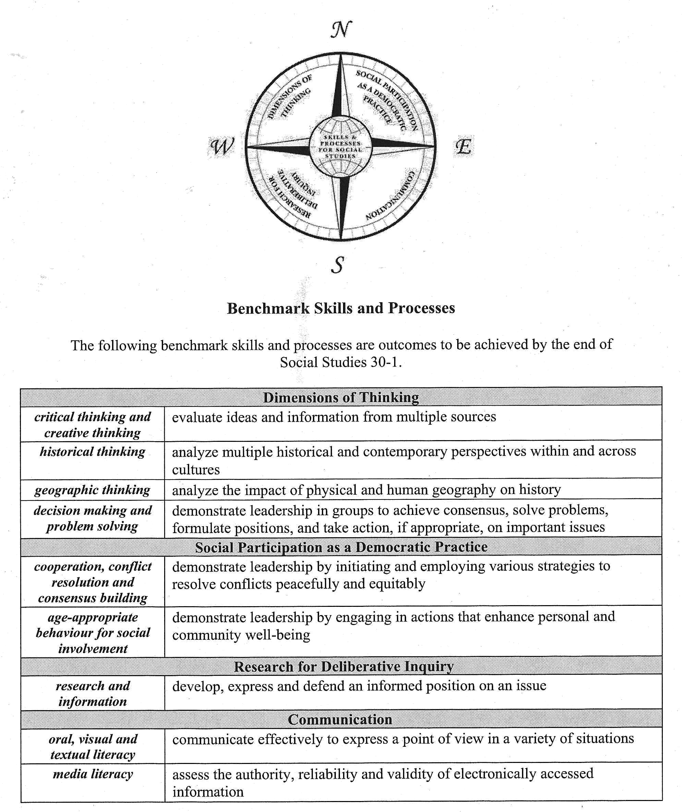
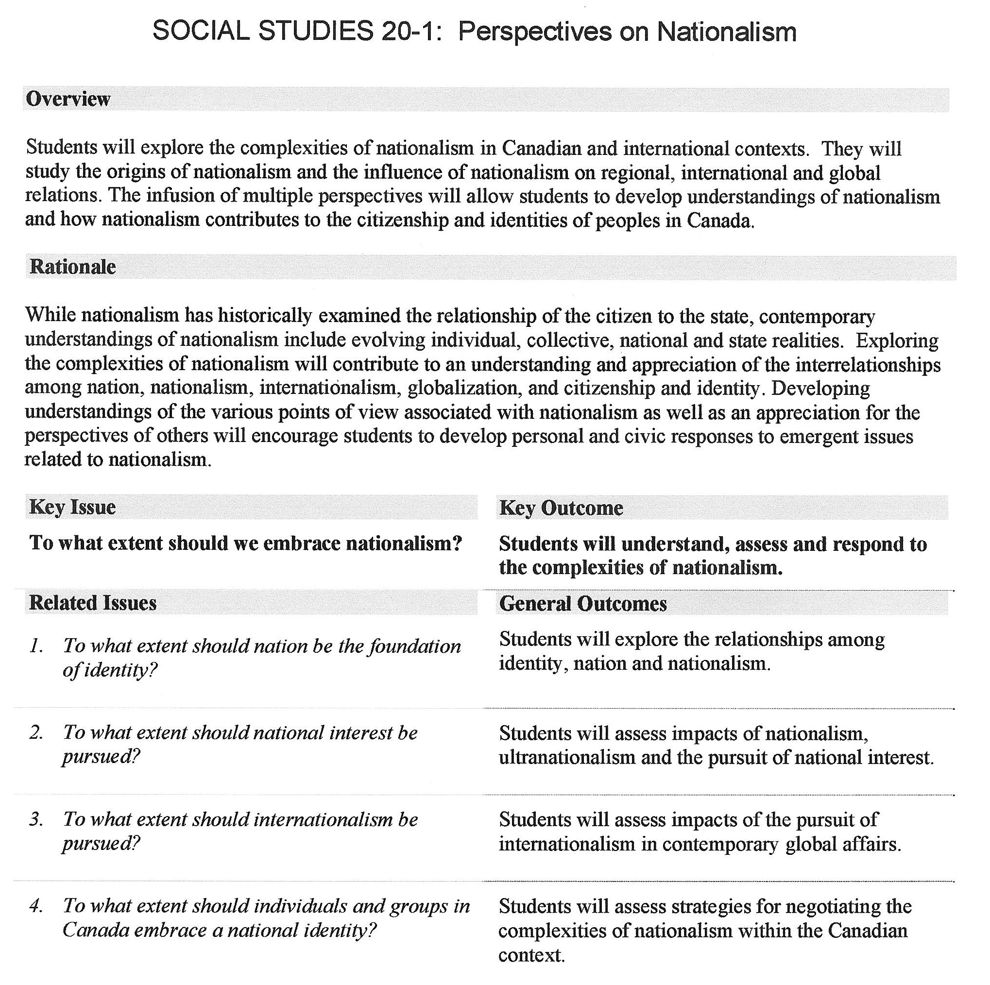

NATI NALISM
SOCIAL STUDIES 20-1
TO WHAT EXTENT SHOULD WE EMBRACE

Attitude and Participation marks will be based on the grid below out of a total of 10, plus the number of homework checks, completion marks & journal entries etc. that accumulate over the reporting period.

Homework assignments, handouts and assigned reading notes are designed to help you meet course objectives and therefore are not meant to penalize you for the wrong answer. On the other hand, there is an obvious difference in how individual students demonstrate effort, thought, accuracy and pride of presentation (i.e. neatness) in their assignments.

- Student is well behaved, prepared and co-operative.
- Attendance and punctuality is exemplary.
- He/she contributes frequently and positively to class discussions and activities.

- Student is well behaved, prepared and co-operative on a regular basis.
- Attendance and punctuality is good.
- Classroom contributions are positive and regular.

- Student’s behaviour is usually positive.
- Occasionally comes to class unprepared or late.
- Contributions are adequate.
- Co-operation, attendance and lates beginning to be a problem.

- Student’s behaviour is not acceptable. Often unco-operative and unprepared. Unexcused absences are an issue. Student’s contribution to class is infrequent and inadequate.

- Student’s behaviour is unacceptable. Unprepared, and unco-operative or lazy. Unexcused absences are at a critical level. Classroom contribution is negative/non existent.

- Student withdrawal

- Your assignment is fully complete and shows exemplary effort.
- All answers have been provided in complete sentences and in proper order.
- All questions have been attempted
- Your understanding of the content of the assignment is clear.
- Your assignment is complete and shows acceptable effort.
- All answers have been provided in complete sentences.
- All questions have been attempted.
- You demonstrate a basic understanding of the content of the assignment
- Your assignment is complete but shows less than required effort.
- Answers have not been provided in complete sentences.
- All questions have been attempted.
- Your understanding of the content of the assignment is difficult to interpret.
- Your assignment is complete but shows little effort.
- Answers are difficult to interpret.
- All questions have been attempted, but those attempted are poorly developed.
- Your understanding of the content of the assignment is unclear.
- Your assignment is complete but shows no effort.
- Answers are difficult to interpret.
- All questions have been attempted, but answers are very poorly developed.
- Your understanding of the content of the assignment is non-existent.
- Assignment is incomplete (this means even one question not attempted) or not handed in.


HABITS OF MIND

According to the Critical Thinking Consortium (CT²), there are key habits of mind of a thoughtful person. These include:

- Open-minded: Are students willing to consider evidence opposing their view and to revise their view should the evidence warrant it?

- Fair-minded: Are students willing to give impartial consideration to alternative points of view and not simply impose their preference?

- Independent-minded: Are students willing to stand up for their firmly held beliefs?

- Inquiring or “critical” attitude: Are students inclined to question the clarity of and support for claims and to seek justified beliefs and values?

NATI NALISM
SOCIAL STUDIES 20-1
TO WHAT EXTENT SHOULD WE EMBRACE

Six Facets of Understanding Rubric – adapted from Grant Wiggins, Jay McTighe (1998) “Understanding by Design”

Explanation | Interpretation | Application | Perspective | Empathy | Self-knowledge
Sophisticated: an unusually thorough, elegant, and inventive account (model, theory, or explanation); fully supported, verified, and justified; deep and broad: goes well beyond the information given. | Profound: a powerful and illuminating interpretation and analysis of the importance /meaning/ significance; tells a rich and insightful story: provides a rich history or context; sees deeply and incisively any ironies in the different interpretations. | Masterful: fluent, flexible, and efficient; able to use knowledge and skill and adjust understandings well in novel, diverse, and difficult contexts. | Insightful: a penetrating and novel viewpoint; effectively critiques and encompasses other plausible perspectives; takes a long and dispassionate view of the issues involved. | Mature: disposed and able to see and feel what others see and feel; unusually open to and willing to seek out the odd, alien, or different. | Wise: deeply aware of the boundaries of one's own and others' understanding; able to recognize his prejudice and projections; has integrity=able and willing to act on what one understands.
In-depth: an atypical and revealing account, going beyond what is obvious or what was explicitly taught; makes subtle connections; well supported by argument and evidence; novel thinking displayed. | Revealing: a nuanced interpretation and analysis of the importance/ meaning/ significance: tells an insightful story; provides a telling history or con text; sees subtle differences, levels, and ironies in diverse interpretations. | Skilled: competent in using knowledge and skill and adapting understandings in a variety of appropriate and demanding contexts. | Thorough: a revealing and coordinated critical view; makes own view more plausible by considering the plausibility of other perspectives; makes apt criticisms, discriminations, and qualifications. | Sensitive: disposed to see and feel what others see and feel; open to the unfamiliar or different. | Circumspect: aware of one's ignorance and that of others; aware of one's prejudices; knows the strengths and limits of one's understanding.
Developed: an account that reflects some in-depth and personalized ideas; the student is making the work her own, going beyond the given—there is supported theory here, but insufficient or inadequate evidence and argument. | Perceptive: a helpful interpretation or analysis of the importance/ meaning/ significance; tells a clear and instructive story; provides a useful history or con- text; sees different levels of interpretation. | Able: able to perform well with knowledge and skill in a few key contexts, with a limited repertoire, flexibility, or adaptability to diverse contexts. | Considered: a reasonably critical and comprehensive look at all points of in the context of one's own; makes clear that there is plausibility to other points of view. | Aware: knows and feels that others see and feel differently; somewhat able to empathize with others; has difficulty making sense of odd or alien views. | Thoughtful: generally aware of what is and is not understood; aware of how prejudice and projection can occur without awareness and shape one's views.
Intuitive: an incomplete account but with apt and insightful ideas; extends and deepens some of what was learned; some "reading between the lines"; account has limited support/ argument/data or sweeping generalizations. There is a theory, but one with limited testing and evidence. | Interpreted: a plausible interpretation or analysis of the importance/ meaning/ signficance; makes sense of a story; provides a history or context. | Apprentice: relies on a limited repertoire of routines; able to perform well in familiar or simple contexts, with perhaps some needed coaching; limited use of personal judgment and responsiveness to specifics of feedback/situation. | Aware: knows of different points of view and somewhat able to place own view in perspective, but weakness in considering worth of each perspective or critiquing each perspective, especially one's own; uncritical about tacit assumptions. | Developing: has some capacity and self-discipline to "walk in another's shoes, but is still primarily limited to one's own reactions and attitudes: puzzled or put off by different feeling. | Unreflective: generally unaware of one's specific ignorance; generally unaware of how subjective prejudgments color understandings.
Naive: a superficial account; more descriptive than analytical or creative; a fragmentary or sketchy account of facts/ideas or glib generalizations; a black-and-white account less a theory than an unexamined hunch or borrowed idea. | Literal: a simplistic or superficial reading; mechanical translation; a decoding with little or no interpretation; no sense of wider importance or significance; a restatement of what was taught or read. | Novice: can perform only with coaching or relies on highly scripted, singular "plug-in" (algorithmic and mechanical) skills, procedures. or approaches. | Uncritical: unaware of differing points view; prone to overlook or ignore other perspectives; has difficulty imagining other ways of seeing things; prone to egocentric argument and personal criticisms. | Egocentric: has little or no empathy beyond intellectual awareness of others; sees things through own ideas and feelings; ignores or is threatened or puzzled by different feelings, attitudes, or views. | Innocent: completely unaware of the bounds of one's understanding and of the role of projection and prejudice in opinions and attempts to understand.
REFERENCES

Alberta Education, Online Guide for Implementation (2007), Edmonton, AB: author. Retrieved on July 14, 2007, from http://www.onlineguide.learnalberta. ca/content-og/ssogscr/html/ summariesofcurrent research.html

Alberta Education, Social Studies 10-1 Program of Studies (2007), Edmonton, AB: author. Retrieved on July 14, 2007, from http://www.education.gov.ab.ca/k_12/curriculum/bySubject/
social/ soc10_1.pdf

Roland Case, Mike Denos, Penney Clark and Peter Seixas (2006) “Teaching about Historical Thinking”, McGraw-Hill Ryerson, 2006.

Grant Wiggins, Jay McTighe (1998) “Understanding by Design”, Merrill Prentice Hall/Association for Supervision and Curriculum Development College Textbook Series, 1998.

Association Considerations, (In Guide to Curriculum Implementation Process (2001) Edmonton, AB: The Alberta Teachers’ Association. P.3,)

Models of Professional Development, (In Guide to Curriculum Implementation Process (2001) Edmonton, AB: The Alberta Teachers’ Association. Pp. 6-7)

Curriculum Implementation Framework, (In Guide to Curriculum Implementation Process (2001) Edmonton, AB: The Alberta Teachers’ Association. pp. 10-15)
My Name is Ms. Klapp. My room is rm. 104 . If you need help let me know. This course can be tough. Good luck! I look forward to this semester.

